ANSCI CODE
ASCII (American Standard Code for Information Interchange) is the most common character encoding format for text data in computers and on the internet. In standard ASCII-encoded data, there are unique values for 128 alphabetic, numeric or special additional characters and control codes. Over the years, several ASCII extended sets have emerged that expand the original set of 128 characters with additional symbols and characters.

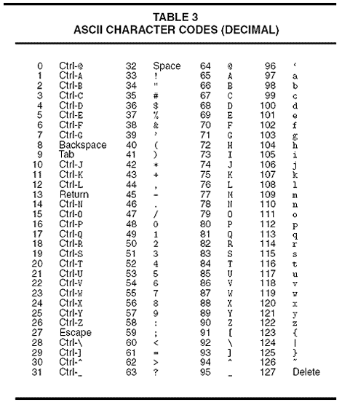

UNICODE
Unicode is an international character encoding standard that provides a unique number for every character across languages and scripts, making almost all characters accessible across platforms, programs, and devices.
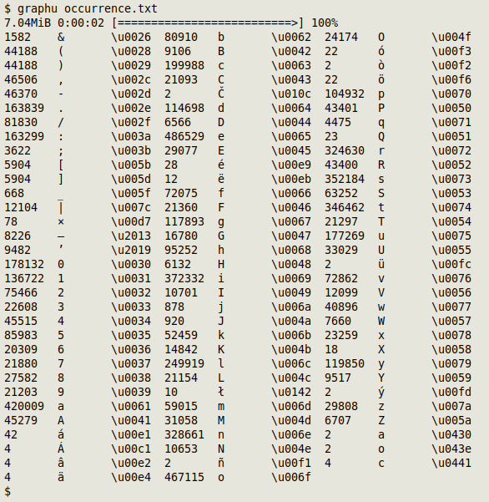

https://www.techtarget.com/whatis/definition/ASCII-American-Standard-Code-for-Information-Interchange
https://www.allbusiness.com/dictionary-ascii-american-standard-code-for-information-interchange-4943214-1.html
https://www.twilio.com/docs/glossary/what-is-unicode
https://www.datafix.com.au/BASHing/2021-09-15.html

